

Information
on the implemented tax strategy
for the fiscal year
1 January to 31 December 2023

TPV Displays
Polska sp. z o.o.

Table of contents
1. Description of the business activities 3
2. About information on the tax strategy 4
3. Information on the processes and procedures in place to manage and ensure the proper performance of tax law obligations 5
4. Information on voluntary forms of cooperation with the National Tax Administration (hereinafter: 'KAS') 8
5. Information on the execution of tax obligations by the taxpayer on the territory of the Republic of Poland, together with information on the number of information on tax schemes provided to the Head of KAS, broken down by taxes to which they relate 9
6. Information on transactions with related parties whose value exceeds 5% of the balance sheet total of assets within the meaning of accounting regulations, determined on the basis of the last approved financial statement of the Company, including entities which are not tax residents of the Republic of Poland 11
7. Information on restructuring activities planned or undertaken by the Company which may affect the tax liability of the taxpayer or related parties 12
8. Information on requests made by the taxpayer for official binding rulings 13
9. Information on tax settlements in territories or countries applying harmful tax competition 14

- 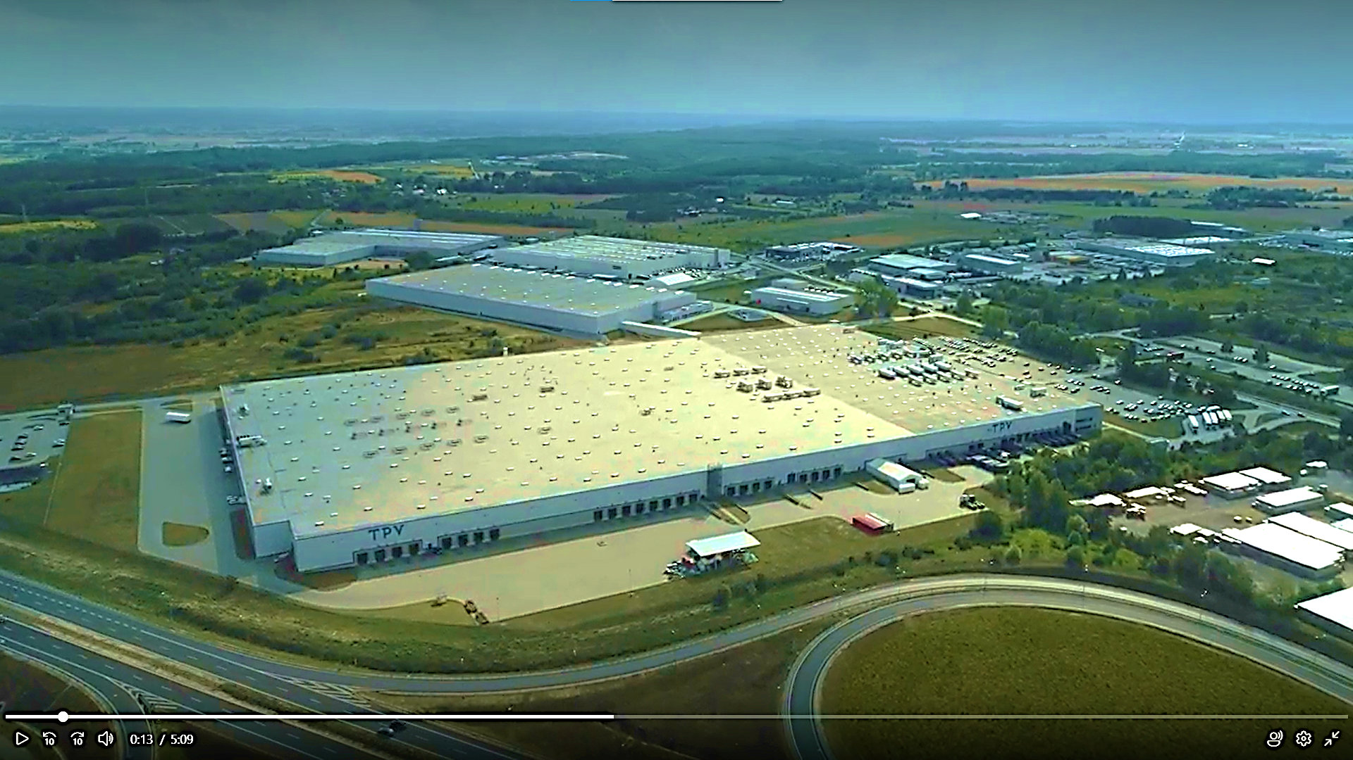Description of the business activities

The core business of TPV Displays Polska sp. z o.o. is the assembly of televisions. The company operates in the Kostrzyn-Słubice Special Economic Zone. TPVD PL is one of the largest entities in Europe involved in the assembly of televisions.
The company acts as the main assembly plant for Philips products in Europe (the Group's other production centers are located primarily in China, as well as in Russia, Argentina, Brazil, and Mexico).
The assembly process carried out by TPVD PL comes down to connecting individual elements of televisions; it is characterized by routine, repeatability - it does not include more complex activities, e.g. designing or customizing individual components of the TV. As a result, assembly activities are performed mainly by lower-level employees serving the assembly lines.
As part of its activities, TPVD PL assumes that the proper performance of tax obligations is one of the basic areas of its responsibility as an entity operating in Poland.
In TPVD PL, tax issues are treated as a matter of corporate responsibility, and paying taxes in the right amount and at the right time is treated as a due return of part of the profit to the society in which the entity operates and uses its resources.
The Company also strives to eliminate tax risk related to business transactions.
TPVD PL complies with tax law regulations, analyzing the tax implications related to the Company's business and individual business operations, as well as managing tax liabilities as part of its operating activities.
Submitted tax returns, tax information and tax settlements are a full reflection of the Company's business activities in the Republic of Poland.
The implementation of the above assumptions is possible thanks to the implementation of tools and procedures aimed at ensuring compliance of transactions with all statutory obligations, managing tax risk in order to minimize it and identifying and immediately removing any irregularities as effectively as possible.

- About information on the tax strategy

This document contains information about the tax strategy implemented for the year 2023 and is the execution of the obligation imposed on TPVD PL, resulting from Article 27c of the Corporate Income Tax Act of 15 February 1992 on CIT (hereinafter: "the CIT Act").
In order to properly perform its obligations as a taxpayer and payer, the Company has a written tax strategy. In accordance with its provisions, it is subject to regular reviews and is adjusted to changes.



- Information on the processes and procedures in place to manage and ensure the proper performance of tax law obligations

The Company's aim is to ensure reliable, correct and timely performance of its obligations in accordance with the current provisions of tax law, as well as timely detection and elimination of irregularities.
In order to achieve the above assumptions, TPVD PL has implemented a number of processes and rules of conduct that regulate the Company's performance of its obligations in the sphere of its taxation.

These processes/procedures concern, inter alia:
- cooperation with related parties;
- conducting settlements with entities from countries and territories applying harmful tax competition
- division of tasks, authority and responsibility within the scope of performing tax obligations and supervision over the correctness of settlements;
- management of personnel and tax knowledge, including permanent supervision of the amendment of tax law provisions and principles of implementation of new statutory obligations;
- verification of factual and legal circumstances concerning the conclusion of business transactions;
- settlement of fixed assets, reporting, circulation of foreign and domestic invoices;
- drafting contracts and assessing transactions from a tax point of view;
- supervision over the correctness of tax settlements;
- cooperation with tax advisors;
- internal tax supervision;
- rules for applying for individual interpretations;
- cooperation with tax authorities, including participation in tax proceedings, including the principles of cooperation with the tax authority in the case of checking activities or tax inspection.

If reliable fulfilment of the Company's obligations in the sphere of taxation requires it, TPVD PL regulates the operating principles in a formal manner, i.e. prepares documents of an official nature, such as procedures.
Tax obligations are fulfilled by designated employees of the Company, who ensure both the correct fulfillment of these obligations and the transfer of knowledge within the Company (including by exercising control, setting guidelines or organizing training on tax issues).
The implementation of the Company's tax obligations is carried out with the involvement of TPVD PL employees and associates, regardless of their functions in the organizational structures. Responsibility for their implementation depends on the nature of the activities undertaken by the Company and the functions of the people participating in them. The Company's overall tax strategy is the responsibility of its Management Board, which, with the participation of the Director of the Financial Division, appoints and supervises organizational units responsible for the implementation of individual tax functions.
The Company has a tax unit dedicated to handling the Company's tax obligations. Tasks related to the settlement of personal income tax are performed by the Department responsible for human resources management in the Company.
The Company's tax policy includes permanent cooperation with an external Tax Advisor.
The processes and rules of conduct used by the Company take into account the specific nature of the company's operation and ensure reliable and timely fulfillment of tax obligations, as well as minimize the risk of tax irregularities.
The formal letters in question constitute internal documents of the Company and are not subject to publication.
TPVD PL has a low tendency to take risks in the area of taxes. Systems and controls, as well as tax management tasks, are designed to enable compliance with tax laws and regulations. The company identifies potential tax risks on an ongoing basis.
Any doubts regarding tax issues are resolved taking into account the provisions of tax law and exercising due diligence in such a way that tax obligations are fulfilled with due diligence in a correct and reliable manner.
Tax risk is regularly analyzed and limited using appropriate measures specified by law.
The company has a tax unit responsible for matters related to the implementation of tax law obligations and tax settlement. This unit performs its tasks based on internal procedures and instructions, ensuring uniformity of operation and appropriate verification of undertaken activities. The Company ensures appropriate financial and human resources and ensures that persons employed in the organizational unit responsible for matters related to the implementation of tax law obligations and tax settlement have appropriate qualifications and experience adequate to the level of tasks entrusted to them within the unit's operations.
As part of the performance of control tasks, the tax specialist, with the participation of external advisors, performs ongoing verification of the correctness of tax liability calculations, prepared declarations, information, notices, statements and other documents required by tax law.
At the same time, TPVD PL constantly monitors changes in tax regulations, assesses tax risk and takes actions aimed at managing and minimizing this risk.
The Management Board of TPVD PL supervises the implementation of the tax strategy, corporate governance and the tax risk management process. The Board understands the importance of tax compliance and how this goal is achieved through internal processes, procedures and best practices.
Tax planning measures are always compliant with tax law, with a low risk of non-acceptance by tax authorities. In case of uncertainty, TPVD PL seeks advice from external advisors.
In terms of tax planning, TPVD PL is guided by the following rules:
1) compliance with all regulations in force in Poland and settlement of due tax liabilities;
2) carefully analyzing legislative changes;
3) not concluding artificial agreements in order to reduce liability towards tax authorities.



- Information on voluntary forms of cooperation with the National Tax Administration (hereinafter: 'KAS')

The Company, as a reliable taxpayer, actively cooperated with the National Revenue Administration authorities, building positive relations based on mutual understanding and trust. The information and documents provided, required by law and in response to requests and questions sent by the tax authorities, were completed on time, to the best of knowledge and in accordance with the applicable legal provisions in this respect.
As part of the cooperation with the tax authorities in 2023, the Company took an active part in social consultations on legal acts in the field of tax law and participated in consultations organized by the Ministry of Finance dedicated to various areas of tax law. These activities were carried out in particular within the framework of the organizations of entrepreneurs and employers with whom the Company cooperates. The Company responds in an appropriate and timely manner to all requests, questions or requests from the tax authorities, in order to properly fulfill its obligations resulting from the provisions of tax law. The Company aims to maintain good and long-term relations with the National Revenue Administration authorities, based on trust and transparency.
The Company received from the Head of the National Tax Administration a decision dated 26 February 2020 on the agreement - unilateral agreement (hereinafter: "APA"; advance pricing arrangement), issued on the basis of the Act of 16 October 2019 on the resolution of double taxation disputes and conclusion of advance pricing agreements (Journal of Laws of 2019, item 2200). The APA is effective for a period of 5 years from 1 January 2019. The APA confirms that the Company's transactions in 2020 were arm's length.


- Information on the execution of tax obligations by the taxpayer on the territory of the Republic of Poland, together with information on the number of information on tax schemes provided to the Head of KAS, broken down by taxes to which they relate

Due to the type and scale of its business activity, TPV Displays Polska spółka z o.o. was required to fulfill a number of reporting and information obligations. All tax obligations were fulfilled in accordance with applicable legal regulations, in compliance with the highest standards, to the required extent and within statutory deadlines.
The Company strives to fulfill its tax obligations in the territory of the Republic of Poland in a correct, timely manner and in accordance with applicable regulations.
To this end, TPVD PL engages qualified employees and experienced tax advisors in conducting its tax settlements.

In the 2023 tax year, the Company fulfilled tax obligations in relation to, among others: to the following taxes and fees:

1) Corporate income tax:
• The Company was a taxpayer of corporate income tax in connection with the activities conducted in the territory of the Republic of Poland,
• The Company makes every effort to fulfill the obligations imposed by law in the scope of submitting the required declarations and tax information and made payments in respect of income tax advances
• At the time of publication of this strategy, the Company had prepared transfer pricing documentation for 2023.
• The Company submitted information on transfer prices to the appropriate head of the tax office together with a statement on the preparation of the above. documentation in accordance with the actual state of affairs and that:
- transfer prices covered by this documentation are established on terms that would be established
among unrelated entities,
- prices used in documented transactions, other than controlled transactions, are established on terms that would be established among unrelated entities that do not have a place of residence, registered office or management board in the territory or in a country applying harmful tax competition,
• the Company's income from activities conducted in the territory of the Republic of Poland is subject to taxation only in Poland. The Company did not conduct business and did not generate income through intermediary entities that would allow tax avoidance,
2) Value Added Tax – The Company was an active VAT payer, filed tax returns (VAT-UE, VAT-UEK, JPK_V7M) and made tax payments in accordance with the relevant regulations,
3) Personal Income Tax – The Company was a personal income tax payer in 2023. The Company filed PIT-4R, PIT-8AR tax returns and made tax payments in accordance with the relevant regulations,
4) Real Estate Tax – The Company was a real estate tax payer in 2023. The Company filed tax returns (DN-1) and made tax payments in accordance with the relevant regulations,
5) Customs Duty – The Company made payments in accordance with the relevant regulations,

The Company settles tax liabilities and files the necessary tax returns within the statutory deadlines.
The Company operates in the Kostrzyn-Słubice Special Economic Zone. Part of the Company's income is exempt from corporate income tax (CIT) based on the decision obtained on investment support.
Due to the scale of TPVD PL's operations, corporate income tax data are published on the MF website:
https://www.gov.pl/web/finanse/indywidualne-dane-podatnikow-cit
In 2023, TPVD PL submitted two reports to the tax authorities on tax schemes referred to in Article 86a § 1 item 10 of the Tax Ordinance in the field of corporate income tax.
The subject of the arrangement is the execution of transactions (payments) that are subject to subsequent inclusion in the costs of obtaining revenues, for the benefit of a related entity established in a country applying harmful tax competition, within the meaning of the Regulation of the Minister of Finance of 28 March 2019 on the determination of countries and territories applying harmful tax competition in the field of corporate income tax..

- Information on transactions with related parties whose value exceeds 5% of the balance sheet total of assets within the meaning of accounting regulations, determined on the basis of the last approved financial statement of the Company, including entities which are not tax residents of the Republic of Poland

In its transactions with related parties, the Company applies such principles as unrelated parties would apply (the so-called market principles). If tax regulations impose such an obligation, the Company prepares transfer pricing documentation and performs relevant reporting obligations in this respect.
In 2023, TPVD PL concluded the following transactions with related parties, including entities that are not tax residents of the Republic of Poland, the value of which exceeded 5% of the balance sheet total of assets within the meaning of accounting regulations, determined on the basis of the Company's approved financial statements for 2023:
- liabilities to related parties for the purchase of raw materials/elements/parts for the production of television sets.
- receivables from the sale of television sets.


- Information on restructuring activities planned or undertaken by the Company which may affect the tax liability of the taxpayer or related parties

TPVD PL does not undertake restructuring activities with the aim of obtaining a tax advantage contrary to the purpose and object of tax law.
Any reorganisations carried out must have an economic and business justification. The Company ensures that they are accounted for in a correct and reliable manner, and achieving this effect is possible through cooperation with professional tax advisors.
In 2023, the Company did not undertake restructuring activities that could affect the tax liabilities of TPVD PL or its related entities. By restructuring activities, the Company understands the merger of companies, the transformation of a company into another company, the contribution to the company in the form of the company's enterprise or its organised part (including as part of the division of the company) and the exchange of shares, as well as debt restructuring.
TPVD PL has also not planned such restructuring activities in 2023 for the coming fiscal years.


- Information on requests made by the taxpayer for official binding rulings

In 2023, the Company did not submit requests for individual tax law interpretations or requests for binding rate information.
In 2023, the Company did not submit any applications for the issuance of:
➢ general tax interpretation referred to in Art. 14a § 1 of the Tax Ordinance,
➢ interpretation of tax law provisions referred to in Art. 14b of the Tax Ordinance;
➢ binding rate information referred to in Art. 42a of the Act on tax on goods and services and
➢ binding excise information referred to in Art. 7d section 1 of the Act of December 6, 2008 on excise duty (Journal of Laws of 2020, item 722, as amended).
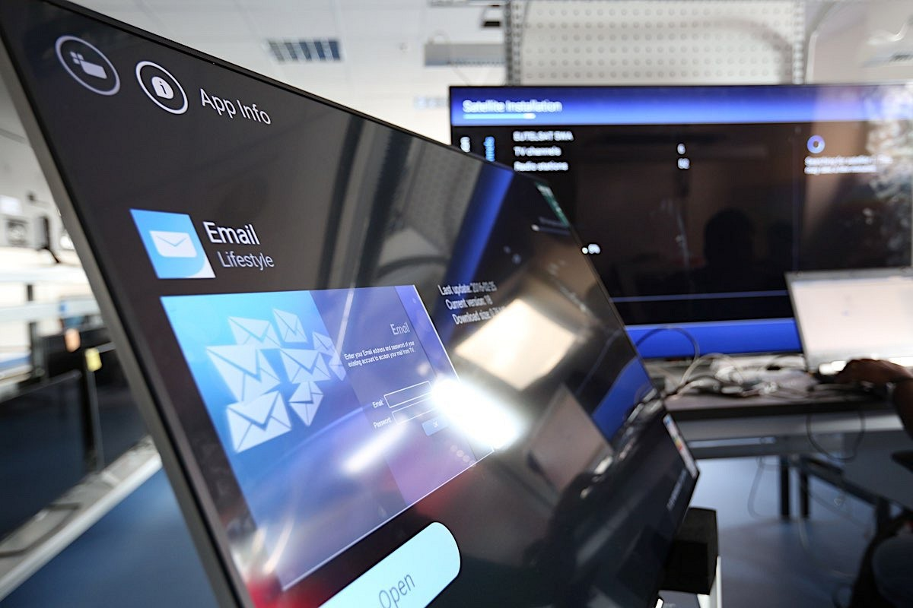

- Information on tax settlements in territories or countries applying harmful tax competition

In 2023, the Company did not make tax settlements in the territories or countries applying harmful tax competition indicated in the executive acts issued pursuant to Article 11j(2) of the CIT Act and in the announcement of the minister responsible for public finance issued pursuant to Article 86a § 10 of the Tax Ordinance Act of August 29, 1997.



